# BDD using Cucumber:

## What is BDD:

BDD stands for behavior driven development and it evolved from TDD (Test driven development). BDD aims to maximize collaboration between DEV, QA and PO in the organization.

You can find good article about BDD from its creator Dan North [here](https://dannorth.net/introducing-bdd/).

## Gherkin:

Gherkin is a textual representation of business functionality in plain English with some predefined format and key words.

For example, typical business functionality can be defined as follows:

**Given** I have a valid account in [www.gmail.com](http://www.gmail.com)

**When** I login with user name as [sample.mail@gmail.com](mailto:sample.mail@gmail.com) and password as password12

**Then** I should be able to login

**And** the application should display all my emails

In this example the highlighted **keywords** are pre-defined key words using which when an application behavior is defined, tool like cucumber can be used to test the relevant behavior of the application.

## Cucumber:

Cucumber is an open source framework in java which aims at enabling BDD in java.

First, the developers, testers and business folks explore the problem domain, and collaborate to produce concrete examples that describe the behavior they want.

Sometimes that discussion is hard, because it throws up all the misunderstandings and assumptions you’d normally discover much later on.

But that's a good thing.

Next, the team use Cucumber to run those examples as automated acceptance tests.

As the team work on the solution, Cucumber tells you which examples are implemented and working, and warns you about the ones that aren’t.

Before you know it, you have one document that’s both the specification and the tests for your software.

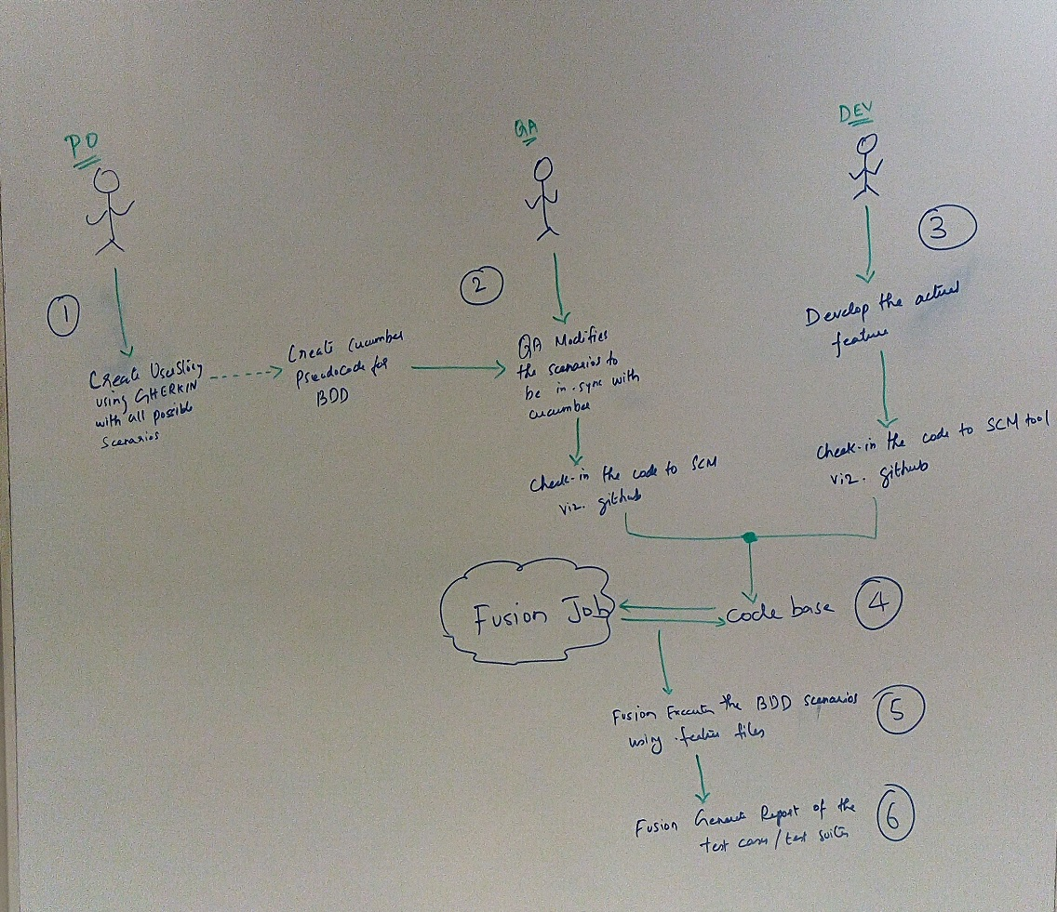

## .feature File:

Application behavior written using gherkin needs to be stored in a file with extension as .feature.

One unit or functional test class needs to be written for every feature file. Cucumber framework automatically recognizes the feature file and its corresponding test file in the build path.\

Test class written following cucumber standard needs to be executed using Junit or any other unit testing framework in java.

## Technical Details:

Project Source Code: <https://github.paypal.com/rboopalan/corp-twitter>

Feature File: <https://github.paypal.com/rboopalan/corp-twitter/tree/master/src/test/resources/com/csc/devops/web>

Cucumber scenario definition: <https://github.paypal.com/rboopalan/corp-twitter/blob/master/src/test/java/com/csc/devops/web/MyLoginStepDefinitions.java>

Triggering Cucumber from Junit test class: <https://github.paypal.com/rboopalan/corp-twitter/blob/master/src/test/java/com/csc/devops/web/MyLoginTest.java>

Cucumber Integration with Jenkins: <https://ci.paypalcorp.com/corp-twitter-1498/job/corp-twitter/>